**Free Goods Reporting Instructions**

1. Runs Free Goods reports:

JDE, 1. Product Data Mgmt Mgr, 18. Pricing Information Menu, 24. Free Goods Report

1. AutoAdd - Report 0004 – run three reports: #1 – order date and ship date current month, #2 – order date previous month, ship date current months, #3 – ship date 2 months back, ship date current months
2. Overrides – Report 0005 - run three reports: #1 – order date and ship date current month, #2 – order date previous month, ship date current months, #3 – ship date 2 months back, ship date current months

Reports will be send via email 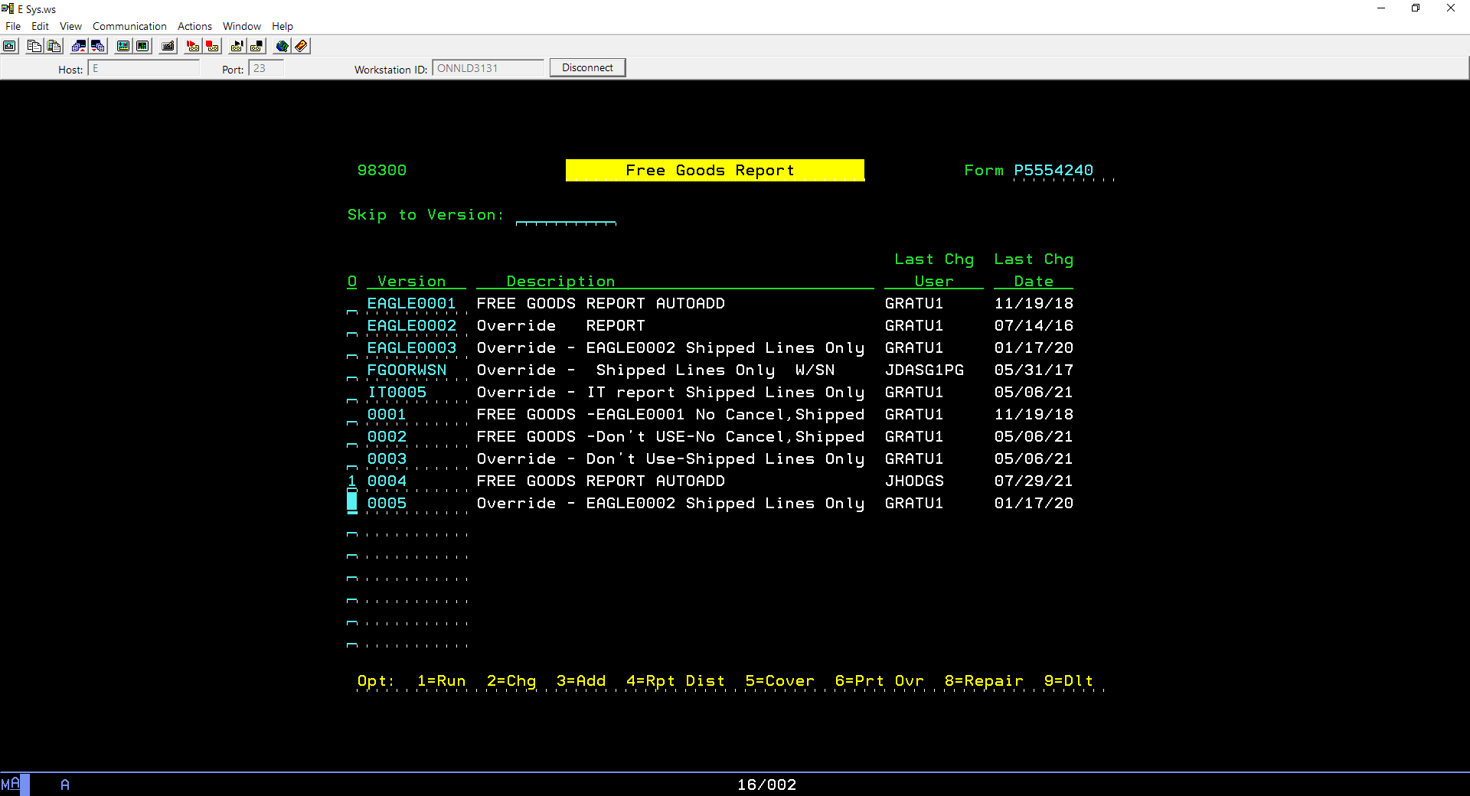

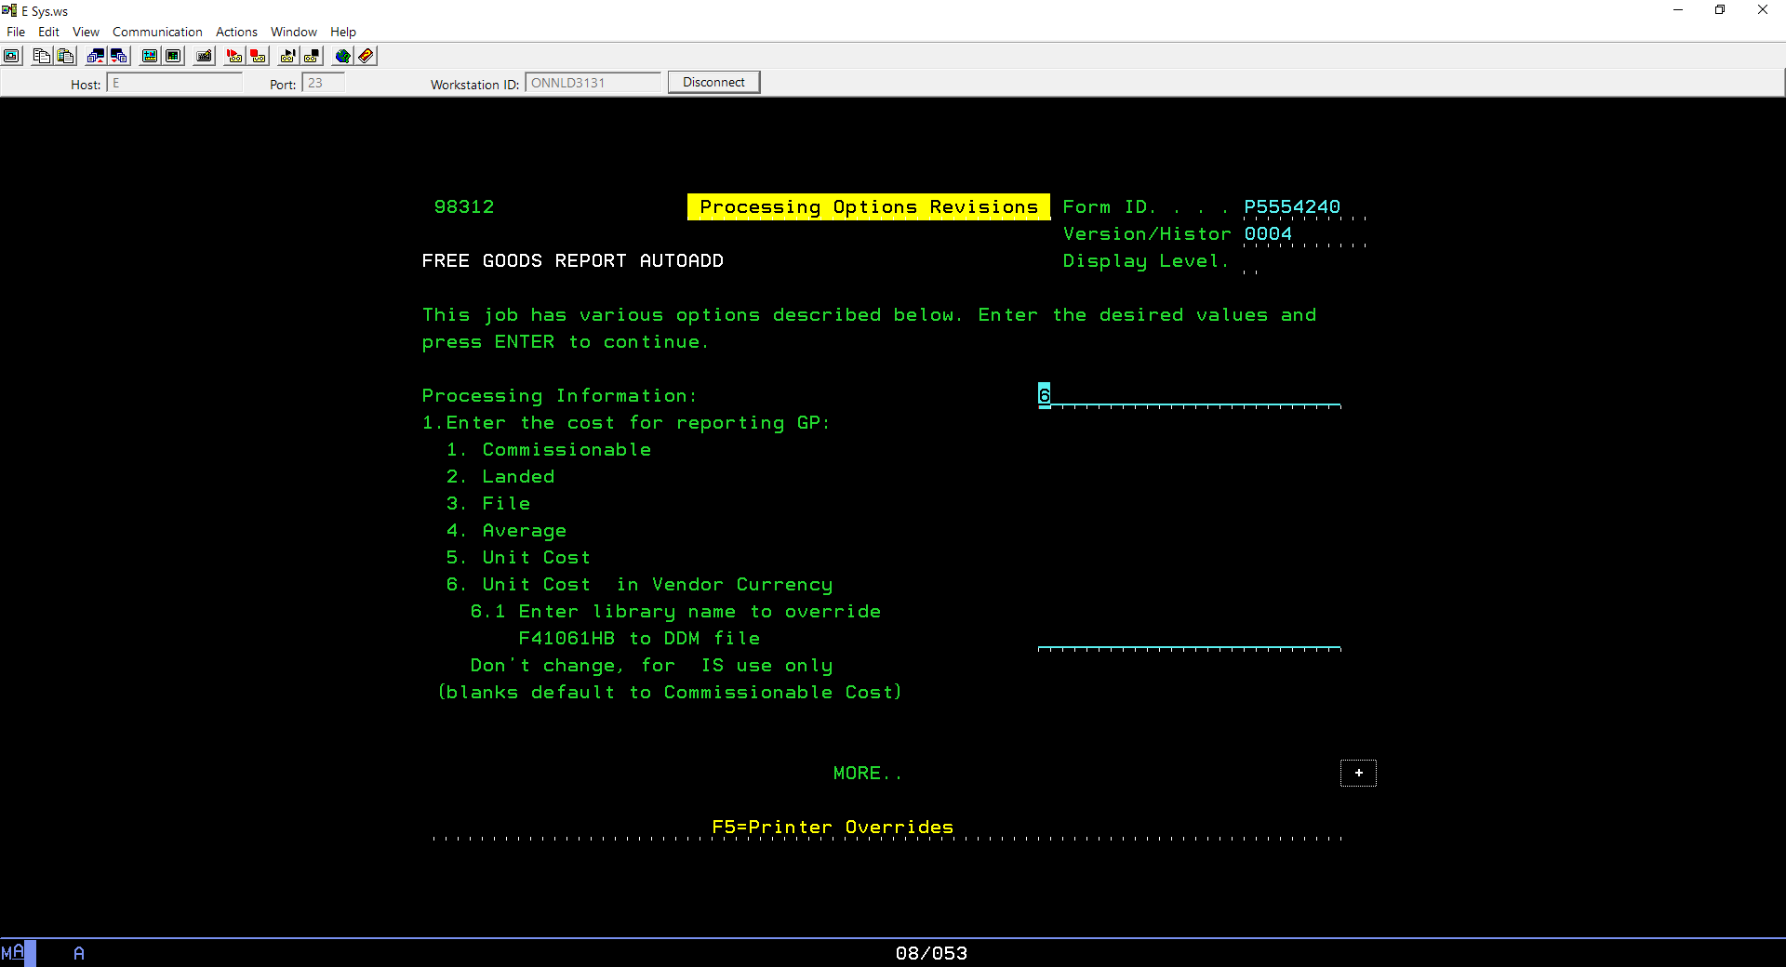

PgDn will allow to change name of the report

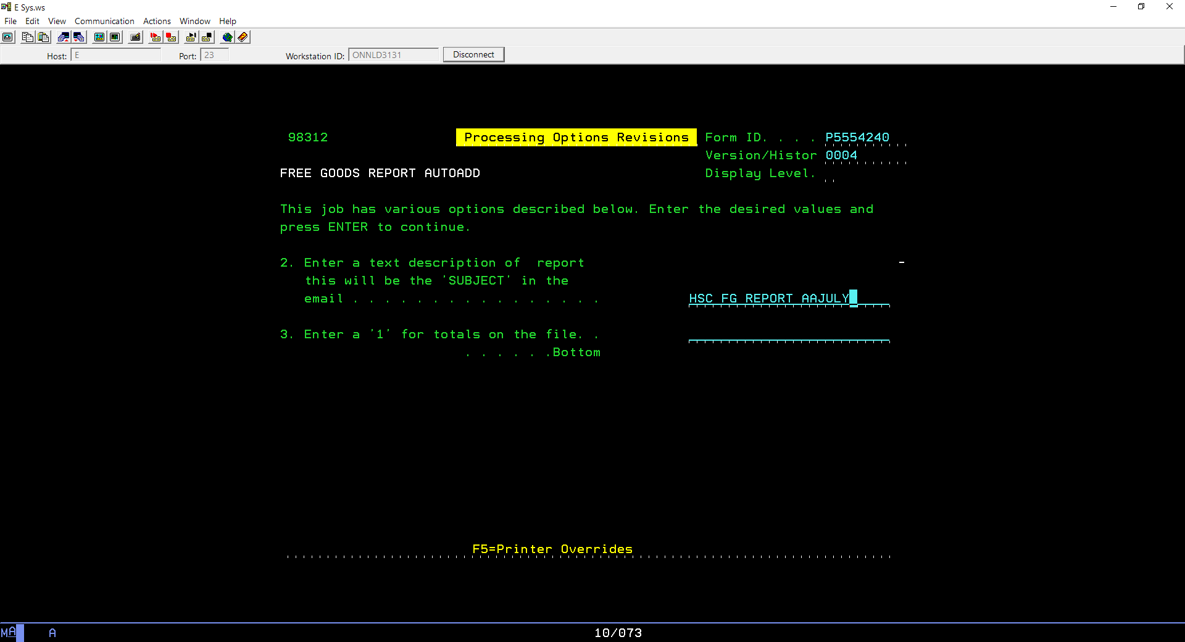

<Enter> to get to Order Date – update dates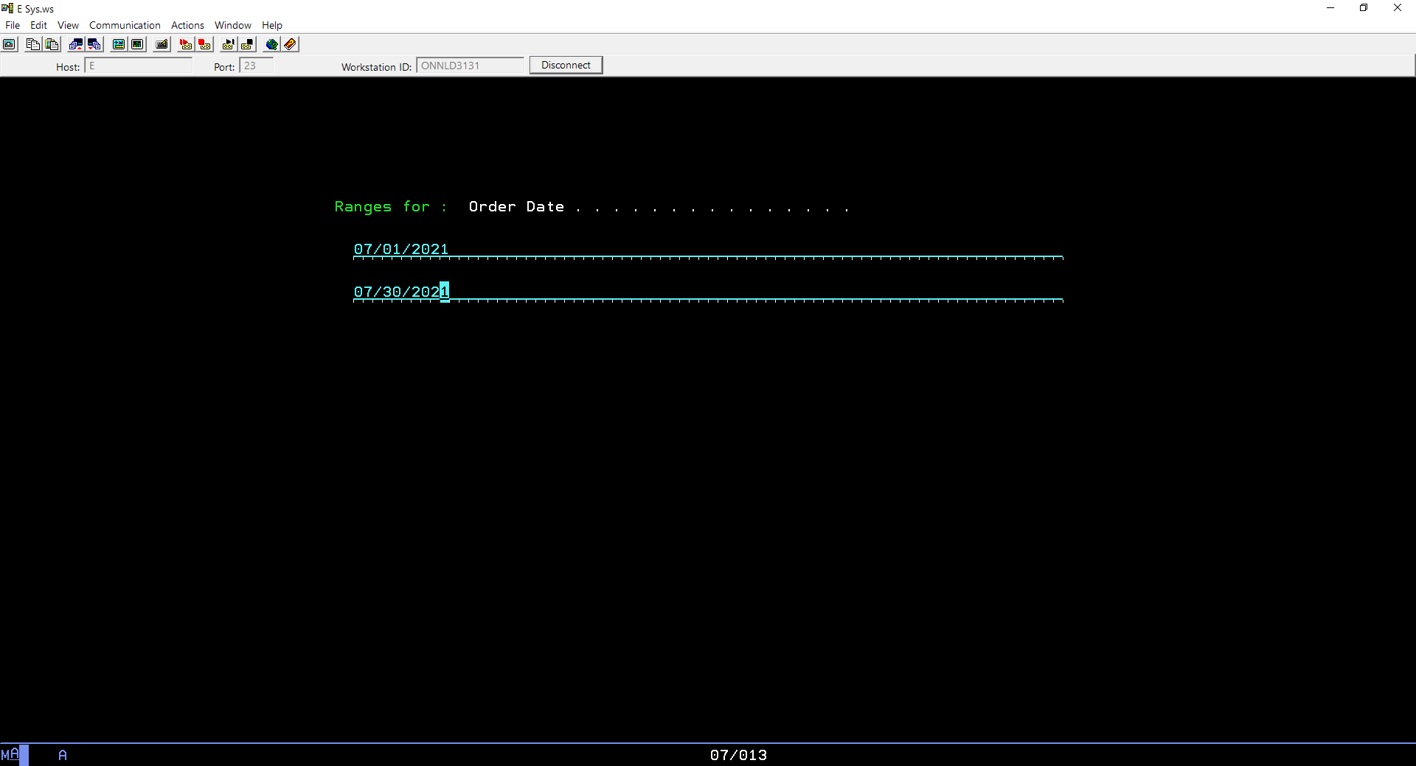

Then populate correct Ship date:

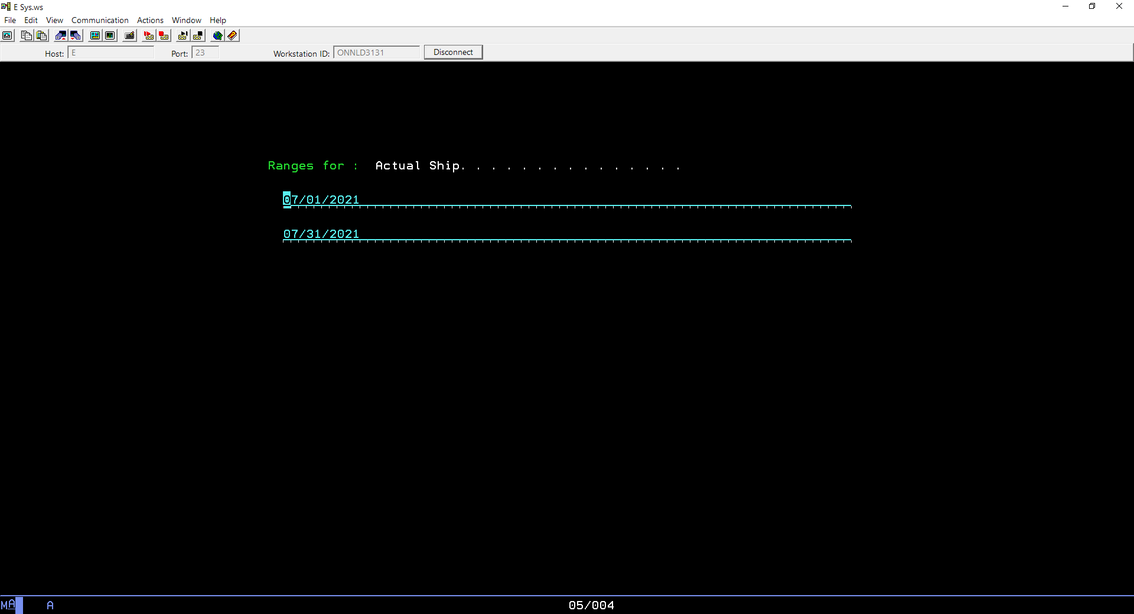

Report will be sent to you via email

1. Open first AA Report and insert Column A and add heading ‘Source’ populate ‘AAJul (AA – auto add + month). Do the same for all other reports and combine them all into one report.
2. Insert six rows on top of the document and copy & past **FG Set up** template. Delete Columns in yellow (B, C, D, E & L) then sort by Row 2 **left to right** (Options – to make the change). Next delete row 2-7
3. Add four columns at far right of the document (Column Z-AC), headers: Brand, Branch, MPC & Cost
4. Use last Item Extract report of the month (S:\Shared_Everyone\Data\2021 Reports) to vlook Brand, MPC & Cost details
5. Filter for Private label and email report to Sylvie Arseneau and remove these items (we do not claim HS brand items promos) from the report
6. Next filter and remove items with MPC 373, 800+ and 900+
7. Delete vendors we do not claim Free Goods from:

* HS Brand/internal: HENSCH, HENGLB, HSCAT, HSDL…
* IT: DELL, CDWCA
* PROCGA – no longer claim FG from this vendor
* Internal promos: Inscam, Jumppl, Cesium

1. Delete

* DIV Code: AZA (Internal account, column V)
* Ord Typ: SX – transfers
* Ln Typ: MS – SDSD
* Ln Typ: CC – misc
* Ln Typ: CP – non-merchandise codes

1. Delete

* Items with cost of $0.00 to $0.05 – these are misc items (labour, travel, rental, stockers, N/C, pumps, etc)

11. Compare Unit Cost (column O) to Cost (column AC) from Item Extract to assure correct Unit Cost is used and in turn Extended Cost is valid. Also, check if vendor currency is accurate

1. Next identify items that cannot be claimed due to chargeback agreement. Following vendors do not redeem CB Free Goods:

* Kulzer
* Medicom
* Novocol
* PDT
* Premier
* Voco

1. Using S:\BR\Public\Customer\202107 CBE1_CustomerExtract.xlsx vlook up customer Bill-To number to populate Branch for each line as well as Current Sales Plan (Column P)
2. On CB Specialty and VPA report (Chad will provide) filter out ‘blank’ in column D (blank means they are not on chargeback based on the sales plan but rather by specialty or division). Vlook up against Current Sales Plan. Copy these sales order for above six vendors and email to Marco C, Chad & marketing team and remove from the report
3. The rest of the data is the estimate for the month. Insert Pivot table to identify supplier currency.



Then insert another table to summarize by vendor & branch and total currency to arrive at grand total in Canadian dollars. Send summary of the estimate to management. **Due 5th of each month**



1. Now sales orders need to be validated. Filter by vendor, isolate 3M (3MDENT & 3MMED – change vendor ID 3MMED to 3MDENT are reported together). Save report 3M, month, year Free Goods. 3M report & SPA are due to vendor by the 10th of the month
2. There are few sources of promos:
3. One off deals (collected during the month – emails) record on spreadsheet for ease of finding during validation process (issues – no HS# or name of approving rep). See **One off Free Goods** from previous month as an example
4. Current promo listing (excel) from Linda Morlog
5. Schein saver (PDF) from Linda Morlog
6. Flyers S:\Shared_Everyone\marketing\Flyers
7. Conventions specials S:\Shared_Everyone\Jonathan Linke\2021 Events
8. If customer did not qualify for free goods, save it on DNQ list for the month. Send it to CSR manager when completed
9. When validation is completed insert pivot table with summary by branch. Reference S:\Purch\FREE GOODS\Free Goods Vendors details.xlsx for vendor details and if Line Charge apply (line charge are $6.00, there are few exceptions)



1. Next SPAs need to be created for each vendor (Heidi is currently looking after this task). Few vendors require offsetting POs, see Free Goods Vendors details.
2. Data from each vendor needs to be compiled into one document for final summary. Again insert Pivot table for currency and another to summarize by branch then add SPA#, Line Charge and PO#



1. Email summary to management and whole document to financial team (Trevor, Jennifer Li, Commissions team). **Report is due by noon on Thursday before month end**
2. Next email each vendor SPA & report for the month (see Free Goods Vendors details) for contacts.